E-commerce Sales SQL Queries

1. **Monthly Revenue Growth:**select SUM(Ecommerce_Sales.Total_Price) as Total_Revenue,DATENAME(MM,Ecommerce_Sales.Order_Date) as Order_Month from Ecommerce_Sales

group by DATENAME(MM,Ecommerce_Sales.Order_Date)

order by Total_Revenue;

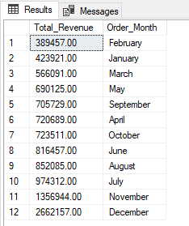

1. **Revenue by Product Category :**

select SUM(Ecommerce_Sales.Total_Price) as Total_Revenue,Ecommerce_Sales.Category from Ecommerce_Sales

group by Ecommerce_Sales.Category

order by Total_Revenue;

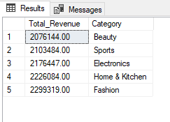

1. **Best Selling category:**

SELECT sum(Ecommerce_Sales.Quantity) as Total_Quantity_Sold, Ecommerce_Sales.Category FROM Ecommerce_Sales

group by Ecommerce_Sales.Category

order by Total_Quantity_Sold desc;

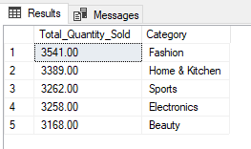

1. **Top 5 Best Selling Product:**

select top 5 SUM(Ecommerce_Sales.Quantity) as Total_Quantity_Sold, Ecommerce_Sales.Product_Name from Ecommerce_Sales

group by Ecommerce_Sales.Product_Name

order by Total_Quantity_Sold desc

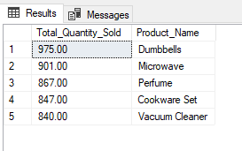

1. **Bottom 5 Worst selling Product:**

select top 5 SUM(Ecommerce_Sales.Quantity) as Total_Quantity_Sold, Ecommerce_Sales.Product_Name from Ecommerce_Sales

group by Ecommerce_Sales.Product_Name

order by Total_Quantity_Sold asc

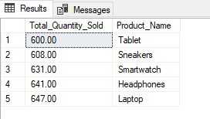

1. **Top 5 most profitable product:**

select top 5 SUM(Ecommerce_Sales.Profit) as Total_Profit, Ecommerce_Sales.Product_Name from Ecommerce_Sales

group by Ecommerce_Sales.Product_Name

order by Total_Profit desc

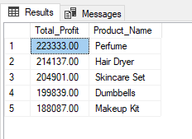

1. **Bottom 5 least profitable product:**

select top 5 SUM(Ecommerce_Sales.Profit) as Total_Profit, Ecommerce_Sales.Product_Name from Ecommerce_Sales

group by Ecommerce_Sales.Product_Name

order by Total_Profit asc

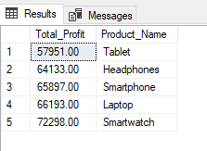

1. **Shipped vs Cancelled vs Returned Orders:**

select count(Ecommerce_Sales.Order_ID) as Total_Orders, Ecommerce_Sales.Order_Status from Ecommerce_Sales

group by Ecommerce_Sales.Order_Status

order by Total_Orders asc

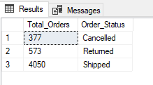

1. **Cancellation Rate by Payment method:**

select Ecommerce_Sales.Payment_Method,

cast (cast (COUNT(Ecommerce_Sales.Order_ID) as decimal(10,2)) * 100/ cas ((select COUNT(Ecommerce_Sales.Order_ID) from Ecommerce_Sales where Ecommerce_Sales.Order_Status = 'Cancelled' ) as decimal(10,2)) as decimal(10,2) )as Cancellation_Rate from Ecommerce_Sales

where Ecommerce_Sales.Order_Status = 'Cancelled'

group by Ecommerce_Sales.Payment_Method

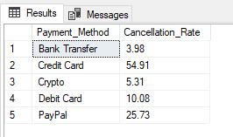

1. **Avg delivery time by region:**

select AVG(Ecommerce_Sales.Delivery_Time_Days) as Avg_Delivery_time,Ecommerce_Sales.Country from Ecommerce_Sales

group by Ecommerce_Sales.Country

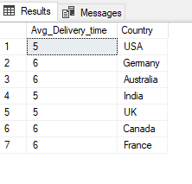

1. **Customer RFM Model;**

with rfm_base as (

select Ecommerce_Sales.Customer_ID,Ecommerce_Sales.Customer_Name, COUNT(Ecommerce_Sales.Order_ID) as frequency,

SUM(Ecommerce_Sales.Total_Price) as monetary_Value,MAX(Ecommerce_Sales.Order_Date) as last_Purchase_date

from Ecommerce_Sales

group by Ecommerce_Sales.Customer_ID,Ecommerce_Sales.Customer_Name)

,

rfm_Score as(

select rfm_base.Customer_ID,rfm_base.Customer_Name, rfm_base.Frequency, rfm_base.Monetary_Value, DATEDIFF(DD,rfm_base.last_Purchase_date,

(select MAX(Ecommerce_Sales.Order_Date) from Ecommerce_Sales)) as Recency from rfm_base)

,

rfm_Rank as(

select rfm_Score.Customer_ID, rfm_Score.Customer_Name,

NTILE(5) over (order by rfm_Score.Recency desc) as R_Score,

NTILE(5) over (order by rfm_Score.Frequency asc)as F_Score,

NTILE(5) over (order by rfm_Score.Monetary_Value asc) as M_Score

from rfm_Score)

select rfm_Rank.Customer_ID, rfm_Rank.Customer_Name, rfm_Rank.R_Score,rfm_Rank.F_Score,rfm_Rank.M_Score,

(CAST(rfm_Rank.R_Score as varchar) + CAST(rfm_Rank.F_Score as varchar) + CAST(rfm_Rank.M_Score as varchar)) as RFM_Analysis,

CASE

when (CAST(rfm_Rank.R_Score as varchar) + CAST(rfm_Rank.F_Score as varchar) + CAST(rfm_Rank.M_Score as varchar)) in ('555', '554', '545', '544') then 'Best Customer'

when (CAST(rfm_Rank.R_Score as varchar) + CAST(rfm_Rank.F_Score as varchar) + CAST(rfm_Rank.M_Score as varchar)) in ('511', '522', '533') then 'Loyal Customer'

when (CAST(rfm_Rank.R_Score as varchar) + CAST(rfm_Rank.F_Score as varchar) + CAST(rfm_Rank.M_Score as varchar)) in ('311', '322', '211') then 'At Risk'

when (CAST(rfm_Rank.R_Score as varchar) + CAST(rfm_Rank.F_Score as varchar) + CAST(rfm_Rank.M_Score as varchar)) in ('555', '112', '121') then 'lost Customer'

else 'regular Customer'

end as Customer_Segment

from rfm_Rank

order by RFM_Analysis desc;